Photos of Laos team
9/2/2016
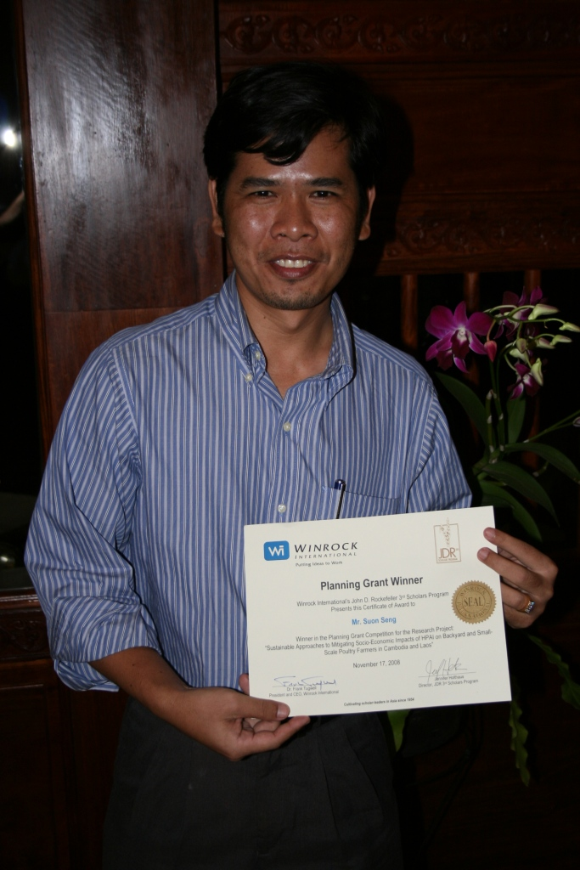
Mr. Suon Seng, Lead Researcher of the JDR 3RD Cambodia-Laos Avian Influenza research team

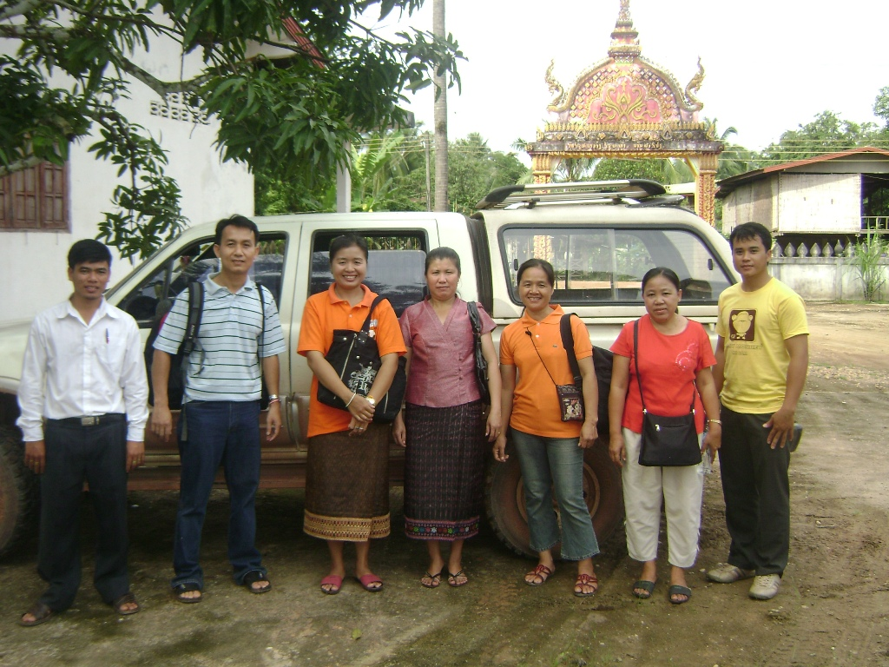
The JDR 3RD Laos Survey team (Yellow shirt: Mrs Khamta, Department of Animal Feed Production, National Animal Health Center (Research Assistant); Black T-shirt: Ms. P Lywan Vilayvanh, Technician, National Animal Health Center; White shirt – Mr. Dongkham - Vet. Technician, National Agriculture and Forestry Research Institute (Research Assistant)

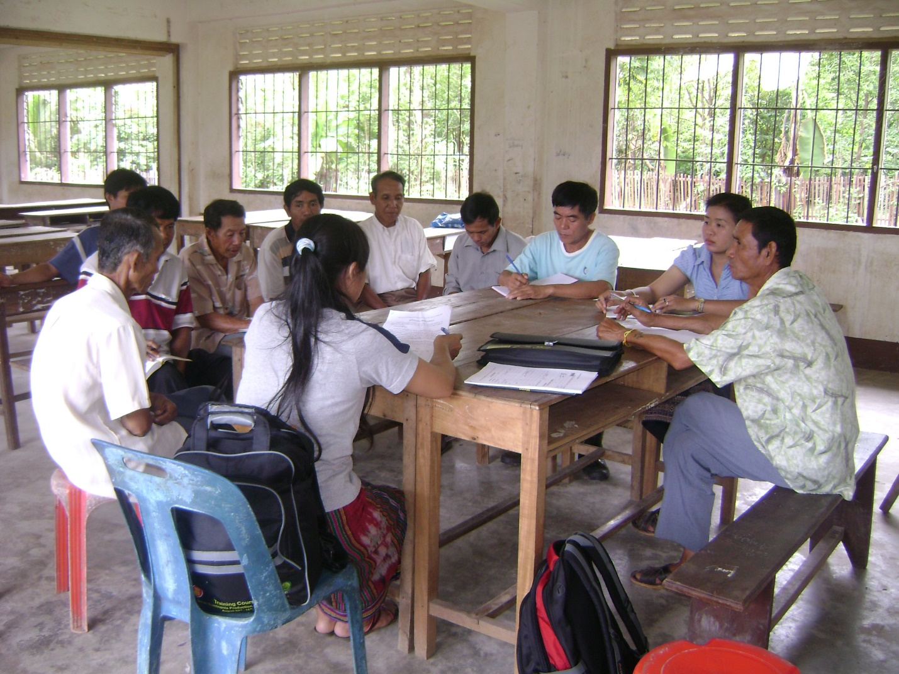
The JDR 3RD Laos research team surveying villagers in Laos
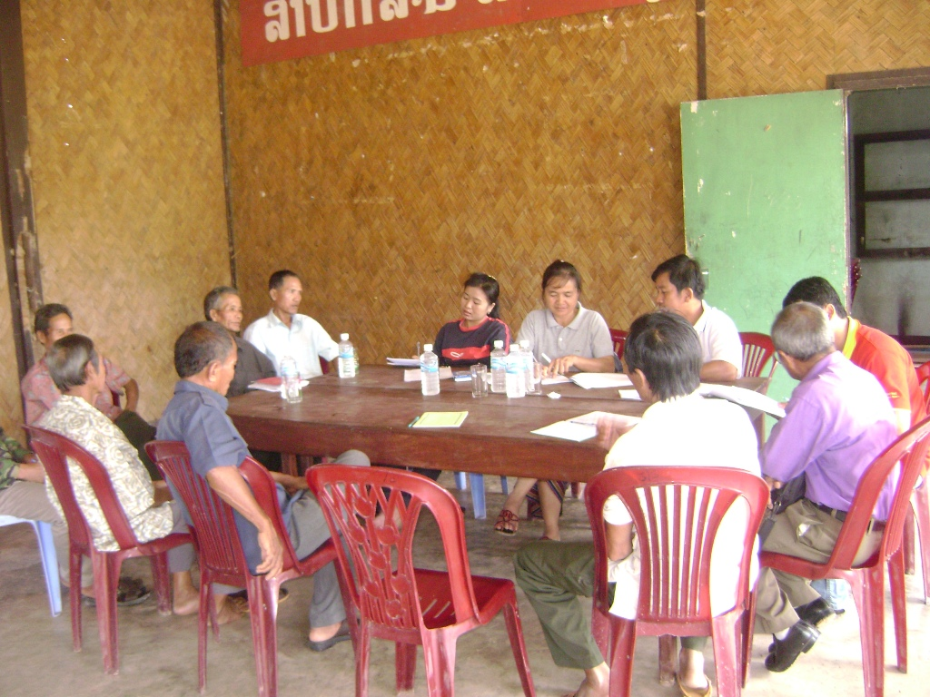
The JDR 3RD Laos research team surveying villagers in Laos

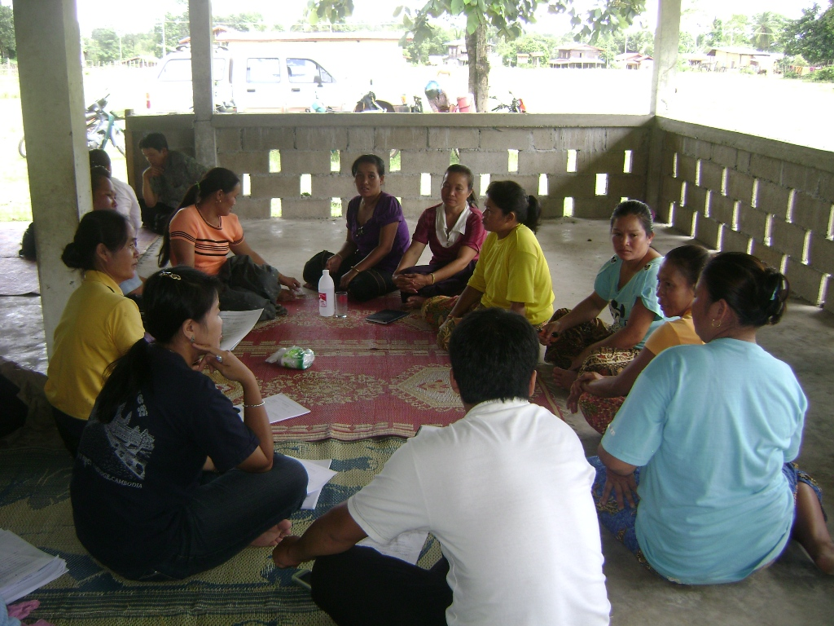
The JDR 3RD Laos research team surveying villagers in Laos

