Scope of Work
Outcome Harvesting Study for the John D. Rockefeller 3rd Scholars Program

UNIT: Analytics, Gender, Inclusion, Learning, and Evaluation (AGILE) Unit
REPORTS TO: JDR3 Project Director
DURATION : September – December 2021
LOCATION : Global

Organization:

Winrock International is a nonprofit organization that works with people in the United States and around the world to empower the disadvantaged, increase economic opportunity, and sustain natural resources. By linking local individuals and communities with new ideas and technology, Winrock is increasing long-term productivity, equity, and responsible resource management to benefit the poor and disadvantaged of the world.

Project Summary

Winrock International created the John D. Rockefeller 3RD Scholars Program (JDR3) in 2004 to continue the Rockefeller family’s longstanding commitment to building the capacity and leadership skills of scholars in emerging countries. The program promotes independent social science research and strengthens analytical skills of young professionals, primarily in Asia. Research themes focus on development challenges facing disadvantaged groups, including women, youth, ethnic minorities and low-income groups.

International Development donors have increasingly noted the importance of linking research and evidence-based practices to development programs to improve efficiency and effectiveness. To do this, it is imperative that implementers address the barriers to generating high-quality social science data. The JDR3 Program uses a participatory, locally-led approach to build the evidence base for project interventions through original social science research that informs programmatic and policy decisions. Research generated under JDR3 helps establish the routine use of evidence in development planning, programming and policy.

JDR3 provides applied research grants to local, early-to- mid-career professionals and historically marginalized researchers, such as women, and ethnic and religious people who have few outside opportunities for funding. JDR3 convenes a Research Advisory Committee (RAC) of local experts representing academia, government, donors and the private sector in each country. The RAC serves as the judging committees and evaluates the research applications and selects the winner. The RAC provides mentoring during the grant competition process to strengthen the analysis and synthesis skills of the researchers and provides quality control and assistance, with outreach to policymakers. JDR3 staff train teams on using research results to inform policy, enabling researchers to advise key decision-makers on policy and practice. The graphic below provides an overview of the JDR3 process.

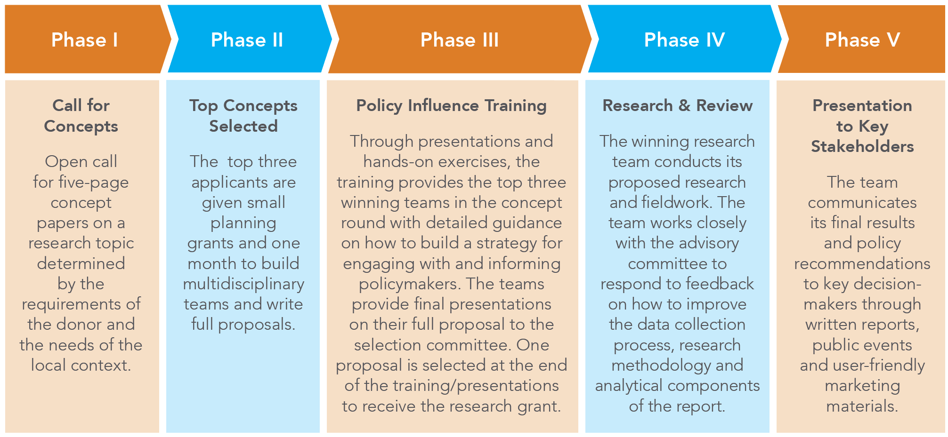

To date, JDR3 has sponsored the following research teams:

Country | Project | Description
Nepal | Hamro Samman Project  (2020 -2022) | Aims to expand the knowledge base on access to justice, trafficking in foreign employment, and reintegration of victims to generate evidence to inform policies
Bangladesh and Malaysia | The costs of migration incurred to Bangladeshi migrant workers  USAID Asia CTIP Project  (2020-2021) | Aims to address the knowledge gap on the costs of migration incurred to Bangladeshi migrant workers seeking employment in Malaysia and study how these costs increase vulnerability.
Bangladesh | Pioneering Mangrove  Valuation Research  (Under USAID CREL project)  (2015-18) | Assess the difference in outcomes when wetland areas in northern Bangladesh are co-managed by community Resource Management Organizations, as compared with privately managed wetlands.
 | Creating A Legal Basis for Community Co-Management of Wetlands  (Under USAID CREL project)  (2016-2018) | A first-of its kind, on-the-ground assessment to determine the economic value of the services provided by the Sundarbans.
Cambodia and Laos | Future of Smallholder Poultry Production in Cambodia and Lao PDR: Uncertainty and Future Prospective  (2009-10) | Assess key factors influencing behavior change related to bio-security practices among smallholder poultry producers in Cambodia and Lao PDR.
Indonesia | Rainfall and Crop Modeling to Improve Rice Farmers’ Yields in Indonesia  (2011-12) | Develop a rainfall model that would provide extension agents and farmers with detailed information on rice planting times and yields.
Myanmar | Socio-Economic Factors Affecting Avian Influenza Prevention and Control: The Case of Village Poultry Farming in Myanmar  (2007-09) | Assess the socio-economic impacts of Avian Influenza on rural poultry farmers in Myanmar.
Vietnam & Thailand | Payments for Environmental Services (PES) to Benefit the Rural Poor Thailand and Vietnam  (2006-09) | Investigate how the rural poor can be compensated for protecting environmental services needed by urban residents, such as clean drinking water from forest watersheds.

- Evaluation Objective and Scope
Winrock International is seeking an evaluation consultant to carry out an outcome harvesting study to facilitate understanding and document evidence of the outcomes of the John D. Rockefeller 3rd (JDR3) Program. It is essential that the John D. Rockefeller 3rd (JDR3) Scholars Program document results and outcomes of the program in order to refine implementation, scale up successful approaches, and sustain continued financial support for JDR3 and also to enroll new projects in JDR3. Conducting an outcomes study would provide JDR3 managers with evidence of the program’s success for use in activities to generate demand for JDR3.

Objectives
Working under the direction of JDR3’s Project Director, collaboratively design and carry out the outcome harvest and analyze findings in order to identify and document evidence of changes in behavior or social factors due to JDR3 program.

Scope
The consultant is expected to design the outcome harvest, collect, review, verify, potential outcomes and collaboratively systematically analyze information and stories related to program results. The consultant will discussions with JDR3 mangers to determine how to act on the findings. Specific tasks and deliverables may include the following:

- Develop a detailed plan for conducting outcome harvest, including timeline.
- Review JDR3 documents to identify potential outcomes.
- Interview JDR3 stakeholders to identify potential outcomes.
- Verify outcomes through third-party sources.
- Analyze and interpret of outcomes.
- Report and present outcome harvest findings
- Minimum of weekly meeting with JDR3 Project Director.

- Evaluation Questions:
Winrock expects the outcomes harvest to address the following questions:

  - How has research capacity improved as a result of JDR3?
  - How JDR3 improved the capacity of women and minorities to conduct research?
  - What have been the effects of the training on policy influence?
  - To what degree have decision-makers revised policies, procedures, practices and behaviors as a result of JDR3 research findings?

- Timeline:
Description of Activities | Expected timeline | Responsible Party
Contracting of Consultant | October 8, 2021 | WI
Conduct Outcome harvest (Design study, review materials, conduct interviews, analyze outcomes) | October 11-November 30, 2021 | Consultant
Collaboratively review and interpret outcomes | December 7, 2021 | Consultant, JDR3 team
Submission of Draft report | December 13, 2021 | Consultant
Review and Feedback on report | December 20, 2021 | JDR3 Team
Final Report | December 31, 2021 | Consultant
- Consultant Qualifications:
The Evaluation consultant should have experience conducting evaluations of donor funded programs. The consultant should at least have a Master’s degree in sociology, economics, international development studies, or other relevant social science subjects with at least five years of experience in project management and conducting project evaluations using qualitative research and participatory evaluation methods. The consultant has led at least two similar evaluations/studies. The consultant will lead and coordinate all aspects of the outcome harvest study, including planning and managing the whole outcome study process from the beginning to the end and submitting required reports. The consultant should be able to communicate both in written and oral English and should be capable of producing the evaluation materials and report in English.

International candidates are strongly encouraged to apply.

To apply for this position, please send your resume and cover letter no later than September 30, 2021.

For information on Winrock International and JDR3 please visit Winrock International or Winrock International » JDR 3rd Scholars Program

