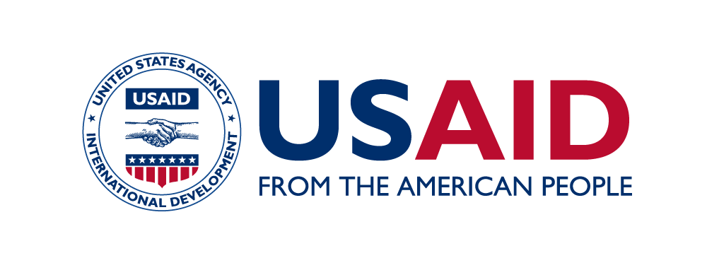

SCOPE OF WORK
Safe Migration in Central Asia (SMICA) Project

POSITION TITLE: JDR 3rd Research Team Coordinator

BACKGROUND
The five-year USAID-funded Safe Migration in Central Asia (SMICA), implemented by Winrock International (WI), works to strengthen the mutual accountability of all stakeholders to become more self-reliant in their efforts to prevent Trafficking in Persons (TIP) and forced labor, protect survivors, and promote safe migration. SMICA supports strengthening of bilateral and multi-country strategies and actions to promote rights-based migration and counter TIP and forced labor; reduces vulnerability of at-risk populations to all forms of TIP and forced labor; and expands and improves identification and assistance to trafficked persons.
POSITION SUMMARY

The Winrock International John D. Rockefeller III Scholars (JDR3) program promotes young independent, social science researchers and strengthens analytic skills in young professionals by giving grants to multi-disciplinary, applied research teams. Research themes focus on development challenges facing disadvantaged groups, including women, youth, ethnic minorities, persons with disabilities, and low-income groups. SMICA will utilize this program to conduct regional research with a focus on migration from Kyrgyzstan to Kazakhstan. Research themes will be discussed with relevant SMICA country teams and CSOs.

SMICA is seeking a 50%-time consultant with a background in CTIP and safe migration or another relevant discipline to develop and manage a policy research grant under the SMICA project. The research team will be located in Kazakhstan and Kyrgyzstan; the consultant will need to travel to both countries regularly or conduct remote work if the situation does not allow for travel.

RESPONSIBILITIES

- Conduct a two-phase research grant competition
• Work with SMICA project staff, Winrock home office staff, and expert in-country advisors to prepare requests for planning grant concepts on the selected research topic
• Jointly with the SMICA team to identify experts to serve on the grant competition advisory/judging committee
• Conduct the grant competition, facilitating the advisory/judging committee to select winners in the planning grant and full grant phases
- Manage a one-year applied research grant
• Work with the team’s Advisory Committee to finalize the research grant budget and scope of work
• Communicate with SMICA project staff, JDR3 home office staff, and expert in-country advisors about the progress and deliverables of JDR3 research team to ensure the research is conducted on time and within budget
• Assess the technical training needs of research teams and identify and organize appropriate support
• Coordinate and host a 1.5-day JDR3 Program training on Using Research Results to Inform Policy Coordinate Advisory Committee and JDR3 home office staff review of draft and final research deliverables
• Proactively identify and address problems and challenges faced by the research team and report them to SMICA and JDR3 home office staff
• Plan and coordinate meetings and events for the research team and key stakeholders to share research progress and results, with the goal of informing policy
• Represent SMICA at meetings and conferences as needed
• Other duties as required

NOTE: All candidates must prepare a written response (no more than 1 page total) to both questions below. Please attach the response to the application. Applications received without a response to both questions below will not be considered.

1. Why is it important to build local capacity in Kazakhstan and Kyrgyzstan for independent analysis of complex CTIP and safe migration problems?

2. What role should applied research play in formulating CTIP and safe migration policies in Kazakhstan and Kyrgyzstan?

QUALIFICATIONS AND EXPERIENCE:

- Excellent written and spoken English and Russian
- Minimum five years of experience in CTIP, safe migration and development sector, including management of development projects
- Excellent management, communication, and organization skills
- Demonstrated track record of effectively supervising staff and coordinating programs with partners from a broad range of backgrounds and experiences
- Strong analytic skills
- Basic computer skills (word-processing, spreadsheets, power-point, and databases)
- Comfortable in high-level representational role
- Comfortable networking and cooperating with other projects.

EDUCATION:

Appropriate Master’s degree (International Development, Sociology, Law, or other fields as applicable to CTIP prevention or protection) or equivalent work experience, Ph.D level research is preferred.

DELIVERABLES

The deliverables of the Coordinator are:
- Prepare requests for planning grant concepts on the selected research topic
- Establish the grant competition judging committee
- Conduct the grant competition, facilitating the judging committee to select winners
- Provide appropriate support to the research teams
- Coordinate and host a 1.5-day JDR 3RD Program training on draft and final research deliverables
- Final report

CONSULTANT METHODOLOGY AND REPORTING

- The Coordinator shall be responsible for performing the tasks noted above.
- The Coordinator will report to the SMICA Regional Coordinator and MEL Manager.
- All deliverables shall be provided in Russian and/or English. Drafts will be shared with SMICA with sufficient time for multiple cycles of review, feedback, and modification as needed.
- Duration and number of working days: The assignment should not exceed 11 working days/month within a 12 month period.

SUBMISSION DEADLINES
Your technical and financial proposal along with CV and replies to the questions mentioned above should be submitted by email to CentralAsiaJobs@winrock.org. Applications should be submitted by 17:00 Almaty time on January 24, 2022. In the financial proposal, specify a justified daily rate, as well as total amount, including all taxes. Applications submitted by the deadline will receive priority consideration.

